**VISUALIZATON TOOL FOR ELECRIC VEHCLE CHARGE AND RANGE ANALYSIS**

**1 DESCRIPTION :**

**1.1 Overview**

A vehicle that can be powered by an electric motor that draws electricity from a battery and is capable of being charged from an external source and have an electric motor instead of an internal combustion engine.

The Electric Vehicle (EV) is not new, but it has been receiving significantly more attention in recent years. Advances in both EV analytics and battery technologies have led increased automotive market share. However, this growth is not attributed to hardware alone. The modern Mechantronic vehicle marries electrical storage and propulsion systems with electric sensors, control, and actuators, integrated closely with software, secure data transfer, and data analysis to form a comprehensive transportation solution. Advances in all these areas have contributed to the overall rise of EV’s, but the common thread that runs through all these elements data analytics.

The new EV’s are combined electrical storage and propulsion systems with electronic sensors, controls, and actuators, integrated closely with software, secure data transfer, and data analysis to form a comprehensive transportation solution.

**1.2 Purpose:**

Electric cars are predicted to be the next disruptive market force for transportation and technology. They have the potential to revolutionize how energy is used, created and redirected.

Electric cars are one solution to the negative environmental impact of conventional cars. However, they have also proven to have many more benefits to society.

The advent of electric cars has called for an improvement in overall energy usage and generation. They have shown how important it is to find alternate sources of fuel and they can positively affect the environment and society as a whole.

**2 PROBLEM DEFINITION & DESIGN THINKING**

**2.1 Empathy Map**

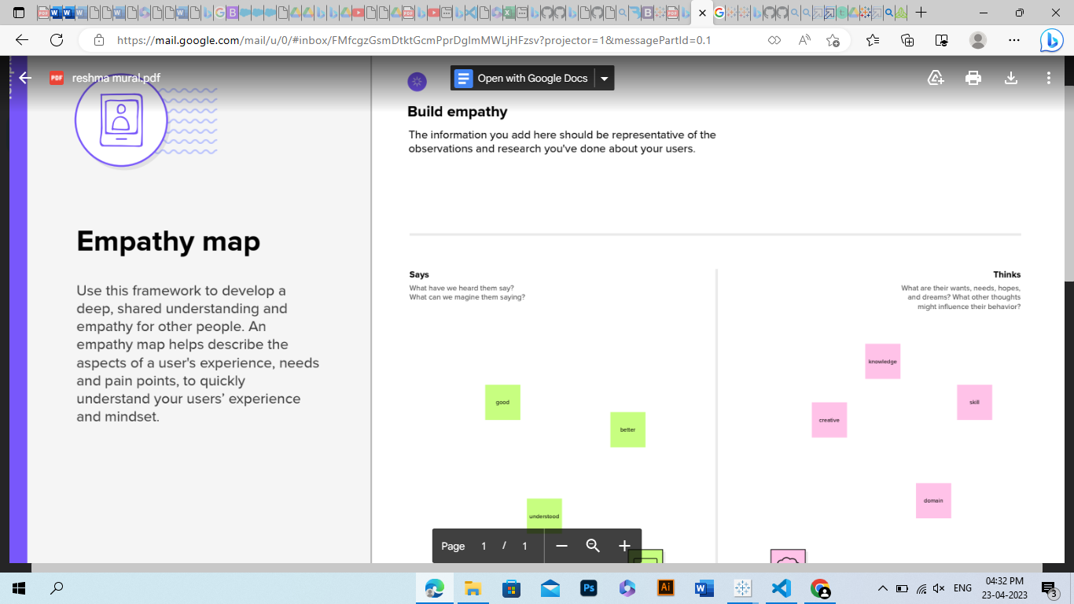

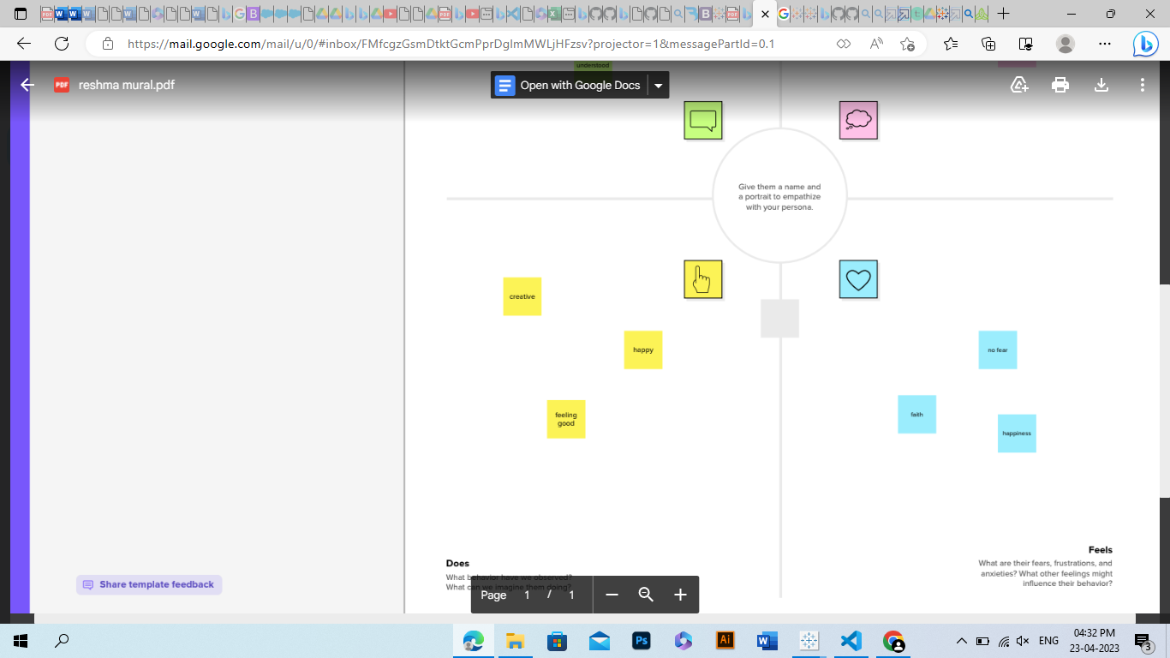

**2.2 Ideation and Brainstorming**



**3 RESULT**

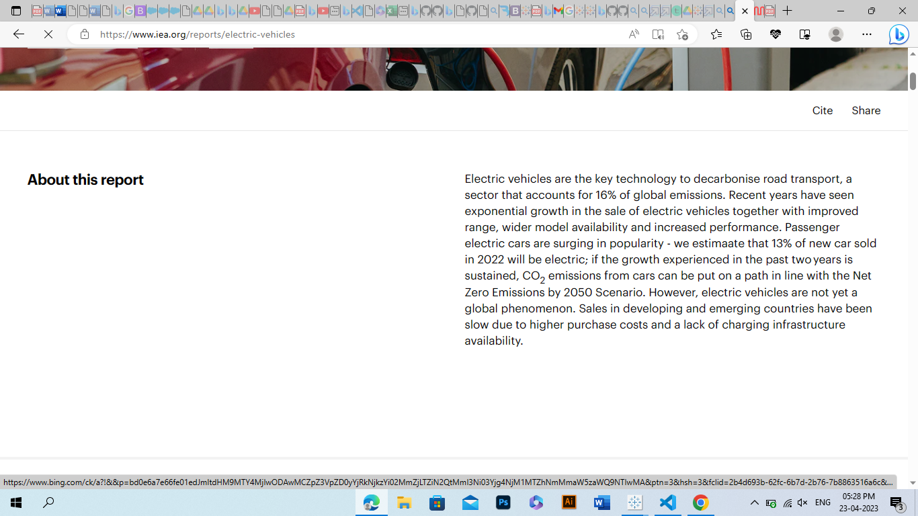

**4 ADVANTAGES AND DISADVANTAGES**

Technological advancements have brought a revolution in different fields. The automotive sector is no exception to it. The latest in this trend is the introduction of Electric vehicle that doesn’t require any fuel to run but use rechargeable batteries. It is a very new concept in the automobile industry. This advanced model of vehicle has been projected as a cost-effective solution of transportation that also contributes towards a safe and healthy environment by avoiding harmful emissions.

In the current situation of rising fuel prices and environmental pollution, one of the best available alternatives for the conventional fuel-driven car is the electric vehicle. Although a lot of people have some apprehension about the mainstream uses of electric vehicles, awareness is growing about how electric vehicles can provide more economically efficient transport and help to reduce greenhouse gasses. Another important aspect of electric vehicles is that it helps in reducing the use of non-renewable energy resources like petrol, diesel, and natural gas which are scarce and need to be preserved.

**5 APPLICATIONS**

Electric car sales reached a record high in 2021, despite supply chain bottlenecks and the ongoing Covid-19 pandemic. Compared with 2020, sales nearly doubled to 6.6 million (a sales share of nearly 9%), bringing the total number of electric cars on the road to 16.5 million. The sales share of electric cars increased by 4 percentage points in 2021. The Net Zero Emissions by 2050 Scenario sees an electric car fleet of over 300 million in 2030 and electric cars accounting for 60% of new car sales. Getting on track with the Net Zero Scenario requires their sales share to increase by less than 6% percentage points per year.

**6 CONCLUSION**

This research targets at the development of electric vehicle market in Washington (WA) State from 1997 to 2023. It involves analysis of market shares for each brand, analysis of electric range, and visualization of the geographic distribution for registered electric vehicles in WA. The overall market size of electric vehicles is continuously growing from 2012 to 2022. Most Manufacturers switched from selling Plug-in Hybrid Electric Vehicles (PHEV) to mainly sell Battery Electric Vehicles (BEV) during this time, and BEV dominated the market in this period. Among all car manufacturers, TESLA, NISSAN, CHEVROLET, KIA, and VOLKSWAGEN are the top five players in the electric vehicle market, and TESLA has been the largest brand in WA since 2018 and owns more than 50% of the market share in 2022. In addition to market size, electric range has also been well researched. Although there are some fluctuations in the growth of electric range over the years, overall, both BEV and PHEV show an increasing trend in electric range. Also, Clean Alternative Fuel Vehicle increased dramatically, by 50% each year, after 2019. King, Pierce, Thurston, Kitsap, Mason, Whatcom, Clark, and Cowlitz are identified as regions where most electric vehicles are distributed within Washington State. In short, BEV is becoming the mainstream in electric vehicles industry, and TESLA is now the largest brand in the Washington State. In the past few years, electric range of BEV has been greatly improved and more and more electric vehicles are now Clean Alternative Fuel Eligible. In Washington State, electric vehicles are mostly distributed around cities like Seattle, and Tacoma, etc.

**7 FUTURE SCOPE**

The future scope of electric vehicles is therefore enormous. We have already seen that technology for these vehicles is here and becoming far more advanced. We now know that such vehicles can provide us with great flexibility and we will soon see that potential.

It will also be interesting to see the impact of regulations which will come into force from the EU and US. These regulations are set to reduce petrol engine vehicles use. As electric vehicles grow in popularity, so will the need to reduce their use. It is clear that there will be a need to develop new zero emission technologies.

It concludes by looking at the present prospects and gives a good guide as to how far technology has come. Future scope is estimated to continue growing rapidly as electric vehicles become more popular.

**8 APPENDIX**

Source code from Different websites of different browsing platforms.

Open PC – open google or any browser – search related topic and gets the stuffs